11776 3rd Street SE
Cooperstown, ND 58425
Phone: 701-797-2174
mail@cooperstownbiblecamp.com
www.cooperstownbiblecamp.com

IMPORTANT INFORMATION:
We’re looking forward to an exciting summer. The staff at Cooperstown Bible Camp is anxiously awaiting the arrival of all the campers. We anticipate the wonderful things God has planned at CBC this summer. Please review the following important information you will need to know.

PAYMENT DETAILS:
If you have a balance, you can pay by logging into your account at
www.ultracamp.com.
Or pay by mailing a check (with notation) to:
Cooperstown Bible Camp
11776 3rd Street SE
Cooperstown, ND 58425
You can also complete payments at Monday morning check-in.

CHECK-IN:
Check-in for all summer youth camps begins Monday at 10 am. Check-in will take place in front of the lodge.

MEDICAL NEEDS:
Please bring all prescription and over-the-counter medications (in the original prescription bottle) in a gallon
Ziploc bag labeled with camper’s name to registration. Please include original and detailed instructions for the
camp nurse for all medical needs.

CABIN PICTURES:
Cabin photos are available for $7.00, and can be ordered online, by phone, or at check-in. They will
NOT be available after Monday check-in.

GIVING TO OTHERS:
Every summer we invite campers to give an offering during chapel. The donation will go towards the
Scholarship Fund to help those in need of financial assistance come and hear the gospel at
Cooperstown Bible Camp. The amount the camper chooses to give will be subtracted from their store
balance.

CAMP STORE:
Campers can purchase a variety of items at the CBC camp store. The store is fully stocked with snacks, sodas, CBC apparel, small toys, gifts for Mom and Dad, and much more! The store will be open once or twice per day. We suggest $25 for spending money.

SEND YOUR CAMPER A LETTER;
We love to give campers mail during their week at CBC. You can write your camper a letter or send a box of goodies. Mail it early in the week so it arrives before your camper leaves. You can also send an email by signing into your account in the Ultracamp portal and clicking “send my camper an email.” Friday is our last mail deliver so please send all emails before 4:00 pm on Friday.

WHAT TO BRING:

Clothing: Clothes, which can get dirty, sportswear, jeans, modest one-piece swimsuit, warm weather
clothes, and comfortable shoes. Please clearly mark clothing. Modesty of dress is expected. Shorts
must be no more than (6) inches above the top of the knee cap. Shorts not meeting length guidelines require appropriate spandex underneath. (No halter tops, or tube tops, or overly tight-fitting clothing, please.) Closed toed shoes if camper is planning to climb the rock wall.

Bedding: Pillow and a sleeping bag. (Sheets and two blankets are acceptable.)

Personal: Towels (one for shower, one for pool), washcloth, soap, shampoo and conditioner, toothbrush and
toothpaste, deodorant, and other toiletries. Notebook, pen or pencil, Bible, camera, flashlight, insect repellent
& sunscreen.

Spending money: For camp store, and offerings. All campers deposit their money in the camp bank
when they register. Your camper’s money is available to them daily. Money not spent will be returned to your
camper during check out, unless you would like the balance to go toward the Scholarship Fund by letting us
know at registration or during check out.

WHAT TO LEAVE AT HOME:
Music equipment, expensive small items, cell phones, iPods & MP3 players, handheld games and computers, knives, fireworks, alcohol, tobacco, cigarettes, firearms, food and candy. If Senior High campers drive to camp, they must turn in their keys at registration and will not be allowed to drive anytime throughout the week.

PICKING UP YOUR CAMPER:
When you come to pick up your camper(s) on Saturday (Thursday for Early Bird Camp), Chapel is at 9:30 a.m. and checkout is at 10:00 a.m. Parents and guests are expected to join their campers in the 9:30 a.m. Chapel service. After Chapel you will go to your camper’s cabin and pick up their belongings (medications will have been returned to them by the nurse earlier that day). Visit the camp store to receive any unused store money, camp photos ordered, and have one more opportunity to shop. A year-round staff member will be at the camp entrance to sign-out your camper.

CHECK THE LOST AND FOUND:
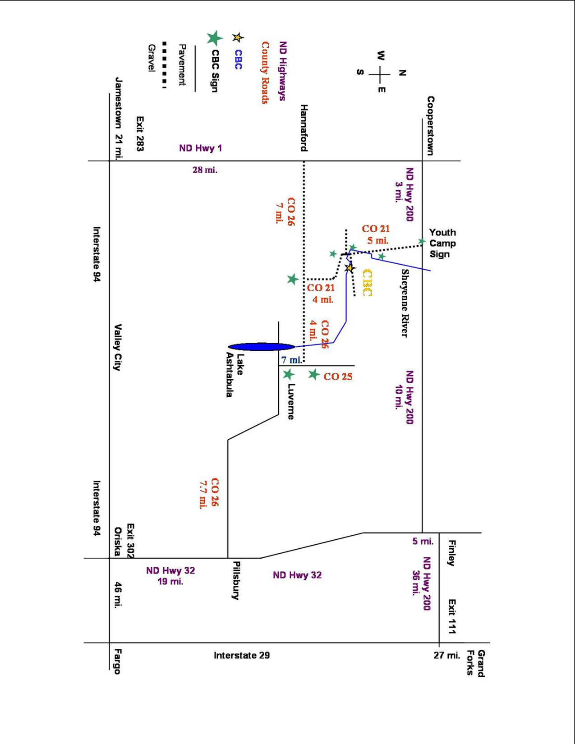
Please check the Lost & Found table at The Lodge when you pick up your camper on Saturday (Thursday for Early Bird Camp) – check for your camper’s things even if they say they didn’t forget anything!

CANCELLATION POLICY:
In the event of a medical emergency where a camper will not be able to attend his/her camp, registration fees
will be refunded, except for a $30 non-refundable registration fee. For non-emergency reasons, refunds will be
given up to 14 days prior to the camper’s chosen week, except for a $30 non-refundable registration fee.
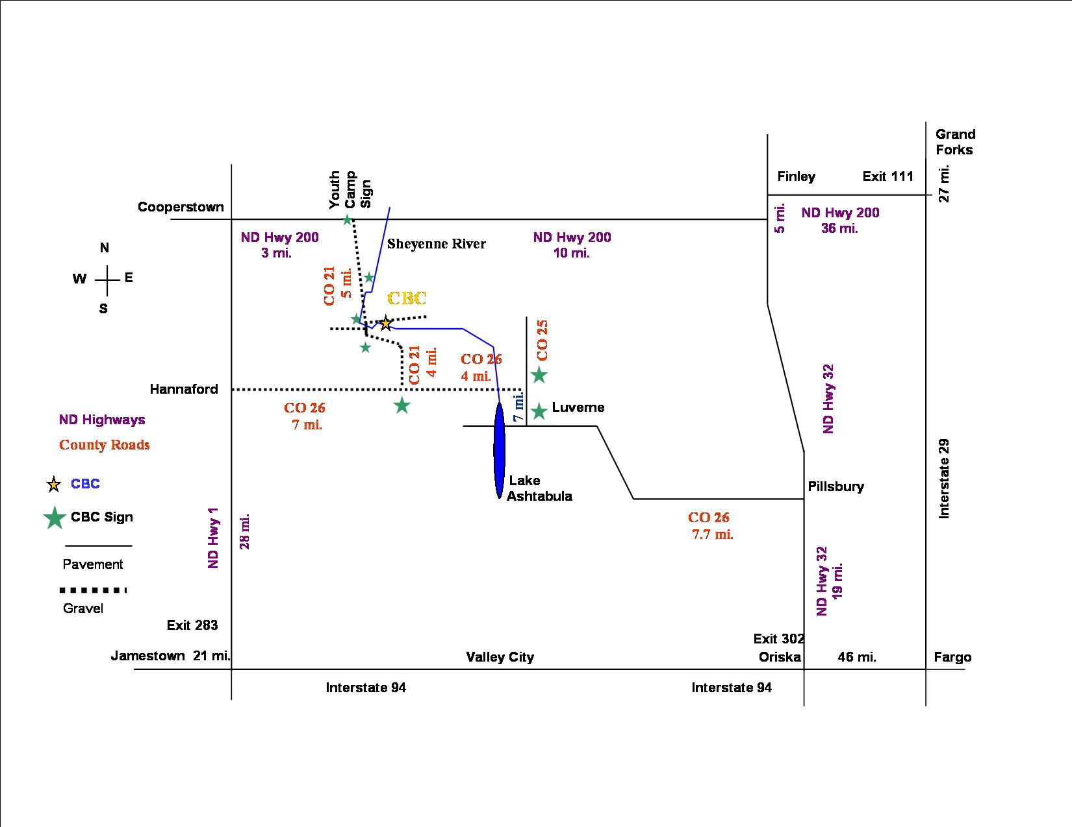
DIRECTIONS TO CAMP:

QUESTIONS:
If you have any questions call or e-mail us at:
701-797-2174
mail@cooperstownbiblecamp.com

