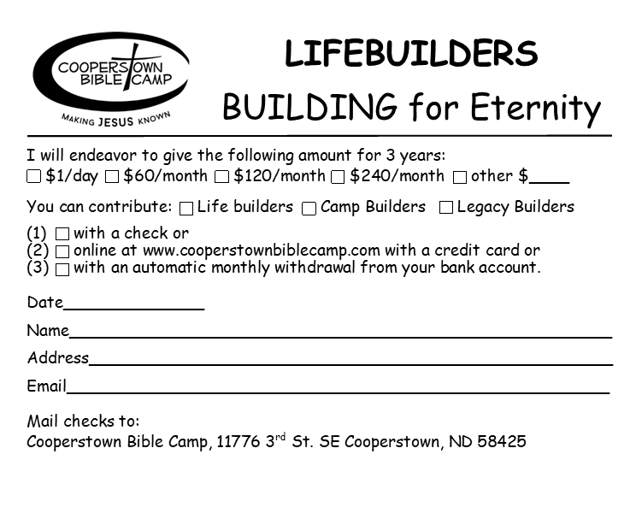

**Please fill out and mail back to Cooperstown Bible Camp

